241901005

EX NO:2 CRACK THE HASHES BY JOHN-THE-RIPPER TOOL

AIM:
To install and crack the hashed passwords using John-the-Ripper tool in Kali Linux.

ALGORITHM:
- Install John-the-Ripper on your system using sudo apt install john
- Prepare the hash file hashes.txt that is to be cracked.
- Run John-the-Ripper specifying the path to the wordlist.txt and hashes.txt
- Monitor the cracking process using status option in another terminal

OUTPUT:

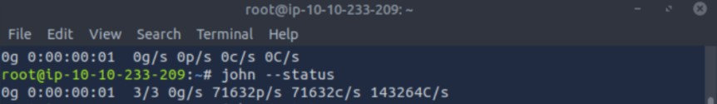

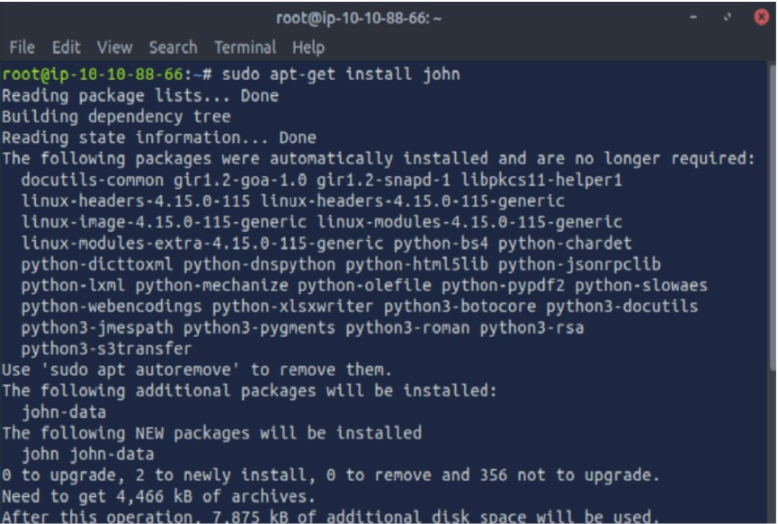
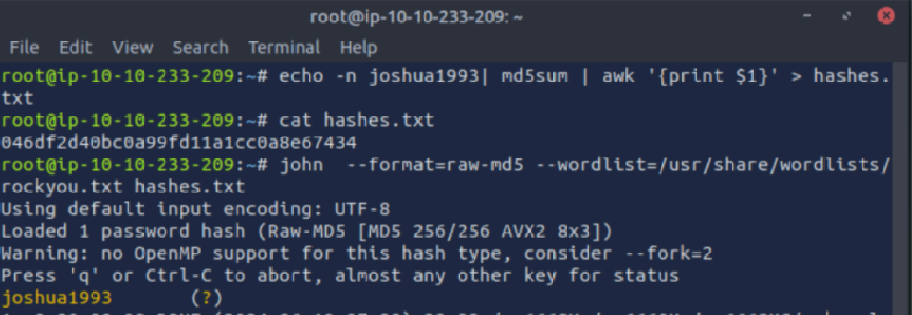

RESULT: Thus, successfully installed John-the-Ripper tool and cracked the password hashes.

